Beacon Labs - Lab Report

Name: INSTRUCTOR | Date: (Date of lab completion)
Lab Name: Android State Inference Attack

Setup:
(Description of the task and how you completed it. Include words and images as necessary)

Objective of this lab

When people think about phishing attacks, many commonly think of emails or fake links that target company email domains. A very prevalent form of phishing attacks target mobile devices though via instant apps and appli- cations. These applications monitor the root device and infer when to inject an application. This exercise will build upon the research paper Detecting and Preventing State Inference Attacks by Possemato, Nisi, and Fratanto- nio, covering vulnerabilities and strategies surrounding mobile devices. In this lab, you will implement and socially engineer an application to monitor state information of a device and steal user information.

Setting up IDE
• Follow the instructions listed within the lab document and submit a screenshot of your running emulated device with the installed packages.
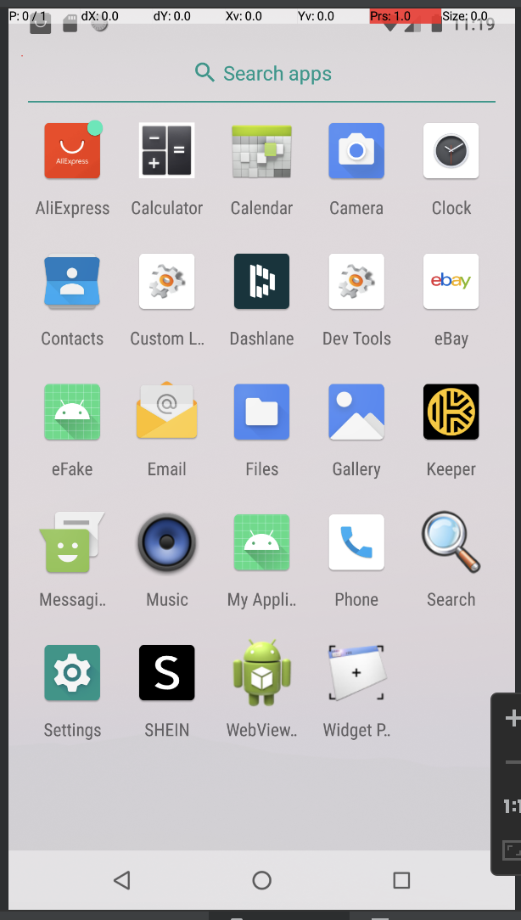
Task Set 1:
(Description of the task and how you completed it. Include words and images as necessary)

Task 1: Game Theory

Action 1.1.1
A) Based on the given game tree, which outcome can you infer has the most utility, and can you make an assumption as to why that might be based on the project description?
• The outcome that has the most utility would be -14 which would be achieved by Client Side -> Fixed Arguments -> Accessible API’s -> Removing Noise -> Accessible API’s. This is because as an attacker, we are seeking to filter out non-candidate API’s that would possibly leak state information, and 14 API’s is a better amount of API’s to test compared to say, 345 API’s.

B) Based on the given game tree, what is one example of an adverse selection when enumerating API’s?
• An adverse selection could be Client Side -> Fixed Arguments -> Accessible API’s -> Removing Noise -> Non -Accessible API’s. This would yield a result of -681 and would drastically change the result of our outcome based on one minor misread of the data returned from the API’s, despite being a minor change in process from the aforementioned answer in question A.

C) Utilizing Bayes’ Theorem, what is the probability that an API was invoked via removing noise through mutated arguments on the client side?
• 57%

D) Utilizing Bayes’ Theorem, what is the probability that an API was invoked via removing constants through static arguments on the client side?
• 43%

Task Set 2:
(Description of the task and how you completed it. Include words and images as necessary)

Task 2.1: Tricking User
The idea behind social engineering is to convince and trick a suspected user into believing that an application is legitimate. If a service appears to be legitimate, it is much more likely a user will feel comfortable providing sensitive information to an attacker or an application. The technique behind this is through modeling an application as close as possible.
Action 2.1.1
A) What common theme do you notice between some of the third-party applications installed on the device?
• The third party applications installed are all e-commerce applications, thus we can assume the user is a frequent shopper.

B) What would be the best part or page of an application to mimic or trick a user and steal user information?
• The most useful page we could mimic on our attack application to steal user information would be the login page.

Action 2.1.2
Create your replicated attack application and submit a screenshot of both your replicated version and the original application.

Helpful links:
- Official Android Mobile UI Design page
- TutorialsPoint's Android Login Screen tutorial
- Android Studio Layout Editor doc page
- Android Studio Resource Manager doc page
This part will be fairly time consuming depending on how familiar you are with UI development. Thankfully, we don’t need to have much going on here, it just needs to look like there is. The text fields should update as you’re typing in them and everything should be laid out as closely as possible to the login page that we’re trying to replicate. Don’t worry too much about font, font size, font weight, and getting colors exactly correct. We’re not looking to be expert UI designers, just getting the feel for what goes into performing an attack like this.
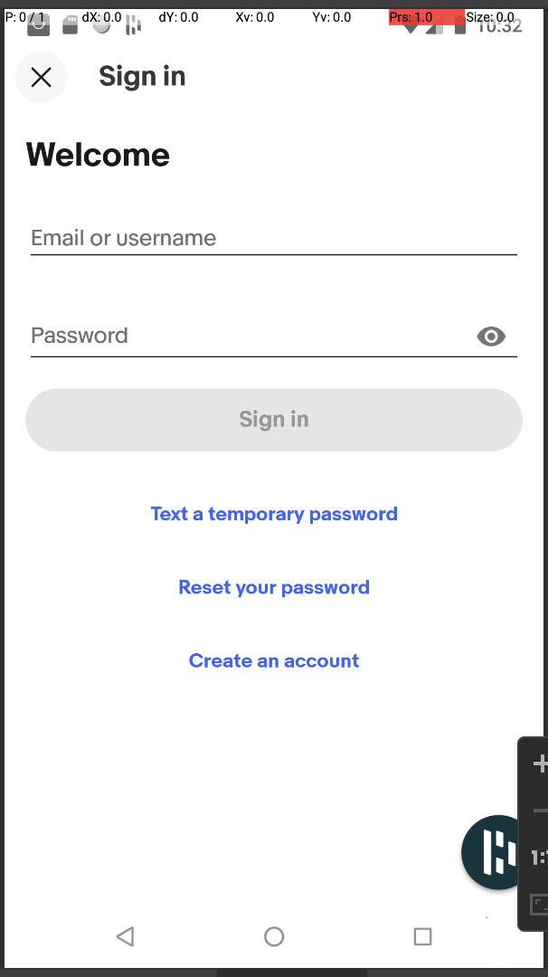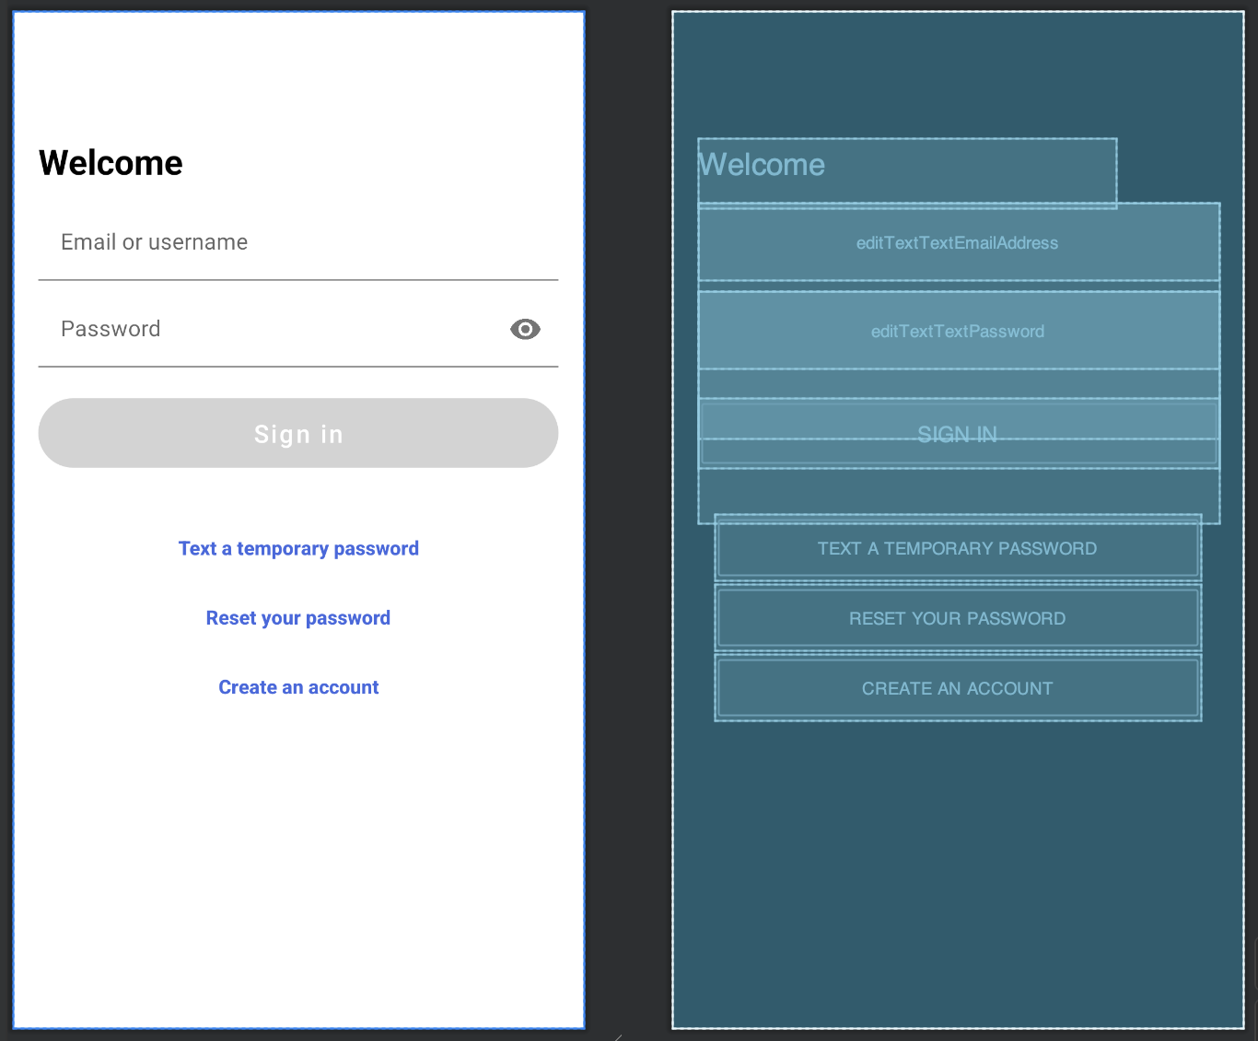
(Description of the task and how you completed it. Include words and images as necessary)

Task 2.2: Stealing Credentials
Now that you have successfully created a page that could potentially trick a user, now it is time to trick the MPM into suggesting credentials and stealing them.
Action 2.2.1
A) Create an input field within your 'activity_main.xml' file that utilizes autofillHints to suggest what type of input to provide and submit a screenshot of your element.
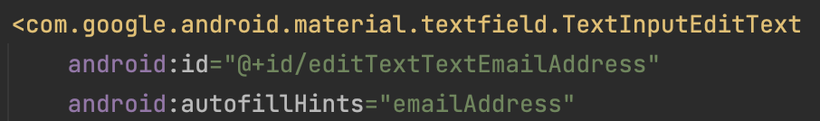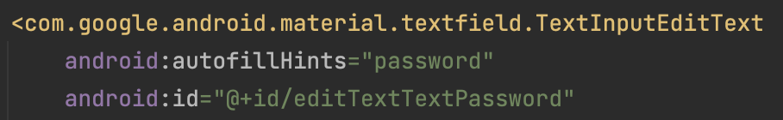

B) Create an on click listener function within your 'MainActivity.java' code that steals credentials from the input field and submit a screenshot of your code.

This function will be in your onCreate method of MainActivity.java. All it’s doing is getting the values of the fields we’re looking for and then logging them to Logcat.
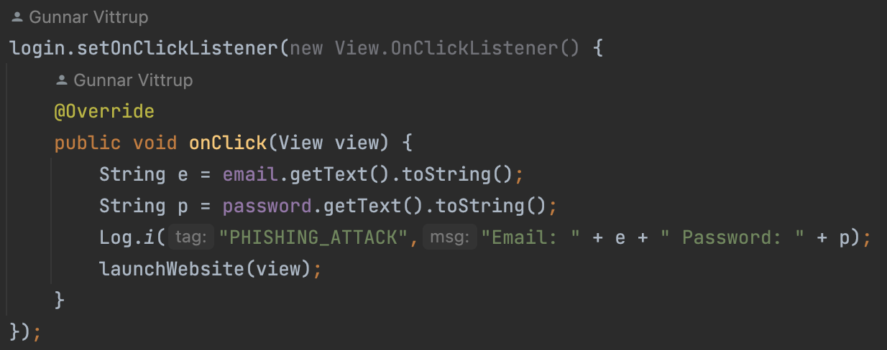

C) Utilize the debug log to print out the stolen credentials to validate that your code performed as expected and submit a screenshot of the output.

Here, all we’re checking for is that the fields that the attacker is replicating are being logged. If we are replicating a login page that just has an email and password field, we’re just looking for an email and password being logged. If there’s additional information such as phone number, country, or address, we’d expect that information to be logged as well.
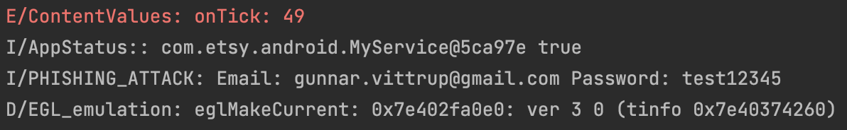
Task Set 3:
(Description of the task and how you completed it. Include words and images as necessary)

Task 3.1: Permission for Usage Stats Manager
While it might seem silly to implement an attack that requires certain signature-level permissions, many real-world apps (both benign and malicious) currently use them, thus it is considered an appropriate threat model.
Action 3.1.1
Create a short section within ‘MyService.java’ that checks whether or not Usage Stats Manager has been granted permission and submit a screenshot of your code.

This method just tells the attacker whether permission has been granted for Usage Stats Manager. Usage Stats Manager itself is a tool for getting usage history and usage statistics for the device that is running. The data it has is aggregated into days/weeks/months/years and through Usage Stats Manager, we’ll later be finding when certain applications were last opened/used. Usage Stats Manager Android Reference sheet
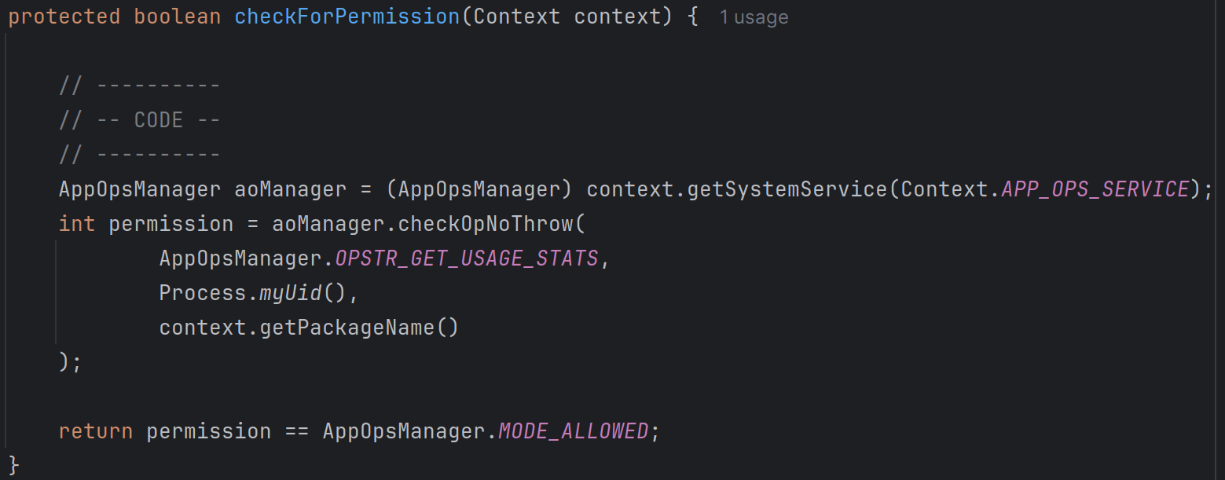

Task 3.2: Implementing Usage Stats Manager
Once you have enabled Usage Stats Manager, you will have access to the contained public methods that will allow you to access state information on the device.

Action 3.2.1
Now that you have permission to Usage Stats Manager, create a function that returns a list of activities and submit a screenshot of your code. Your output should replicate the provided figure.

First we check for permission in the current app’s context. If we don’t have permission, we log that permission is denied and that we’re opening the Settings page to acquire the necessary permissions. In a real-world scenario, we wouldn’t want to be logging this as it would give away part of our attack vector. We then create the Intent to open Settings to the page where we can find the permission to allow UsageStatsManager for our application. We then call startActivity to open Settings. In a real-world scenario we’d likely want to do additional checks afterwards to verify that permission was granted but for the sake of the lab, we chose to just assume that the user gives permission.

Once we confirm that we have permission, we want to get the launch intent for our application, this is part of a later step so disregard this for now, we’ll come back to it later. We then want to get a reference to UsageStatsManager from our application’s context. Using that reference, we query it for usage statistics using the queryUsageStats method, documentation found here, using the weekly time interval, from the start time, to the current time. This gets use the list of all packages that have been run during that time frame. We then update the startTime variable to the current time so that the next time the service runs, it acquires up-to-date information. We then do more logging, if the list is empty, we log that it’s empty, otherwise we log that it’s not empty. This is purely for debugging purposes and can be left out with no issue. Finally, in the for loop we simply log the package statistics. We chose to log the package name, the last time it was used, and the current time. There will be more done in this for-loop later.
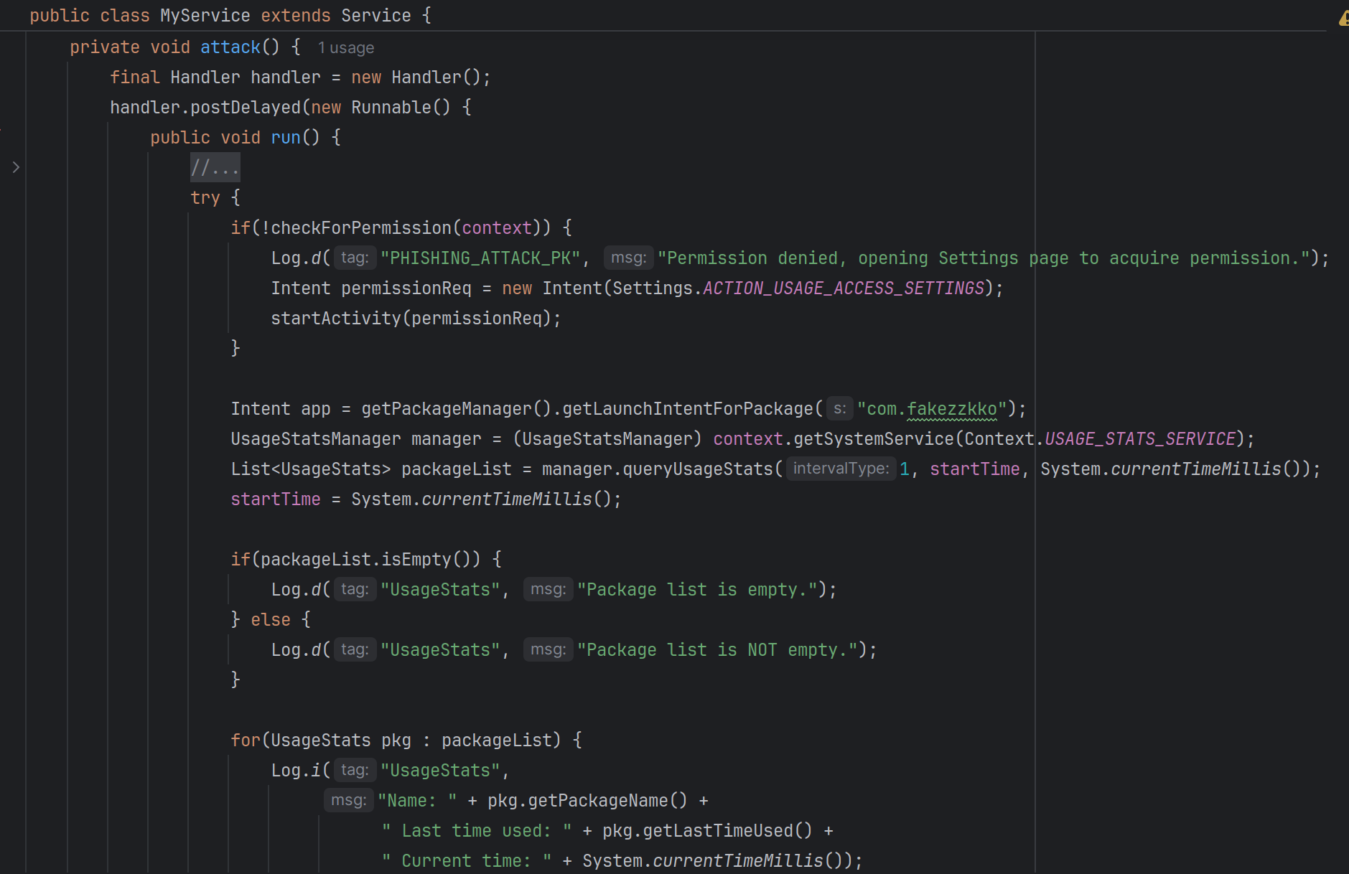
Task Set 4:
(Description of the task and how you completed it. Include words and images as necessary)

Task 4.1: Hijack Activity Via View Intents Through Injection
Here, you will combine techniques learned in the previous modules to in- ject your activity. Through the list of services you identified via the Usage Stats Manager, choose a target application to monitor that is different than the application you selected to replicate. Do this by isolating the target application from the list returned from Usage Stats Manager and create a conditional that identifies when that application is opened, and using View intents inject your application as if it were prompting the user to log in. Once the user clicks ’log in’, create another ’event listener’ and utilize a separate View intent to return the user back to the original application as if they never left it in the first place.

Action 4.1.1
A) Create a section that isolates your target application through monitoring the USM list and injects your malicious application via a view intent. Submit a screenshot of your code.

And now we’re at that point where we’re doing more in that for-loop. The first thing we want to do after printing the package names is to check if our target app is present. To do so, we defined the constant TARGET_APP to be the name of the app we’re targeting, in our case this is ”com.etsy.android” and is defined as a member of the MyService class like such: private final String TARGET_APP = “com.etsy.android”;. If our target app is found, we log that it is and then check our timer flag variable (another class member of MyService, defined as public int timerFlag = 0;). If the timer flag is 0, then we haven’t seen it yet and we need to grab the package’s last time used field. We do so, storing it in the targetLastTime member variable (defined as public long targetLastTime; in MyService) and then set timerFlag = 1. We then proceed to check if our target’s last time isn’t the same as the current package’s last time used and our target app flag is false. If both are true, we launch our attack application (which you’ll remember we defined the Intent for it previously when printing the packages for Usage Stats Manager). Once the attack application has been launched, we update targetLastTime = pkg.getLastTimeUsed(); and then set the targetAppFlag = true; so that the attack application only runs once per service launch.
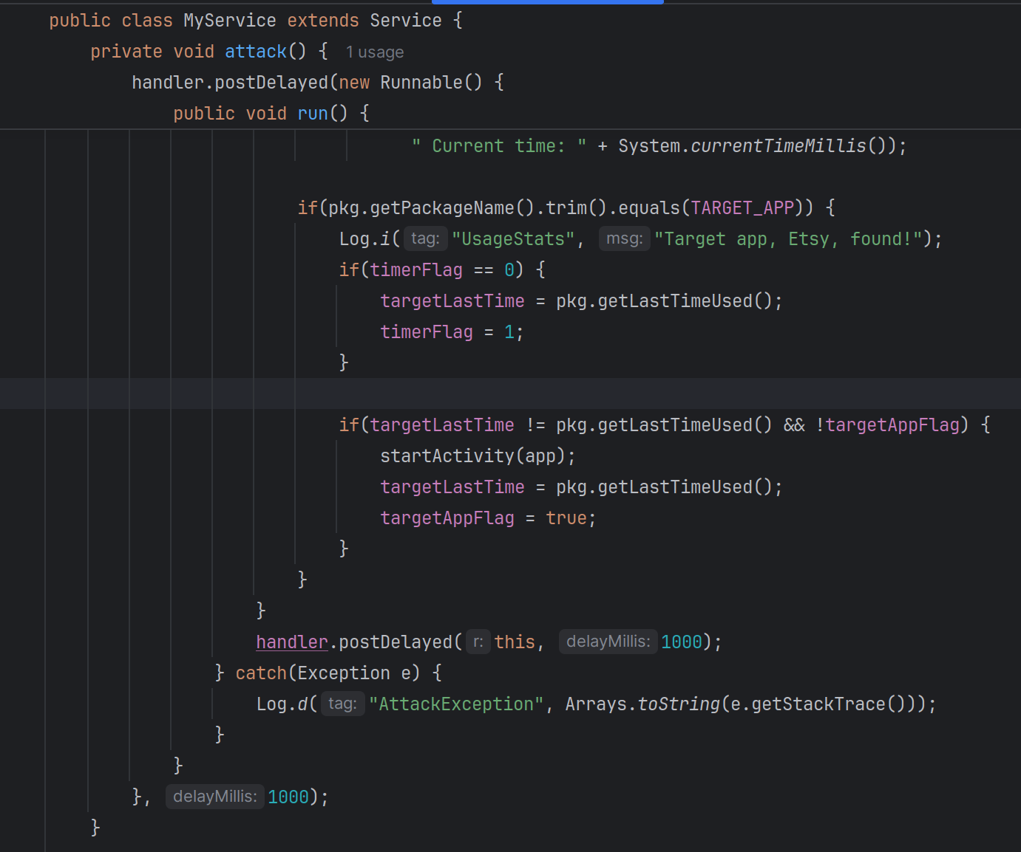

B) Once you have injected your application, create a section that returns the user back to the target application after you've intercepted their credentials in a suspected 'log in' attempt. Submit a screenshot of your code.

Here, all we do is get the appropriate launch Intent for the app we’re stealing from and then try to launch it. If the launch fails, handle it gracefully so the user doesn’t notice anything.
